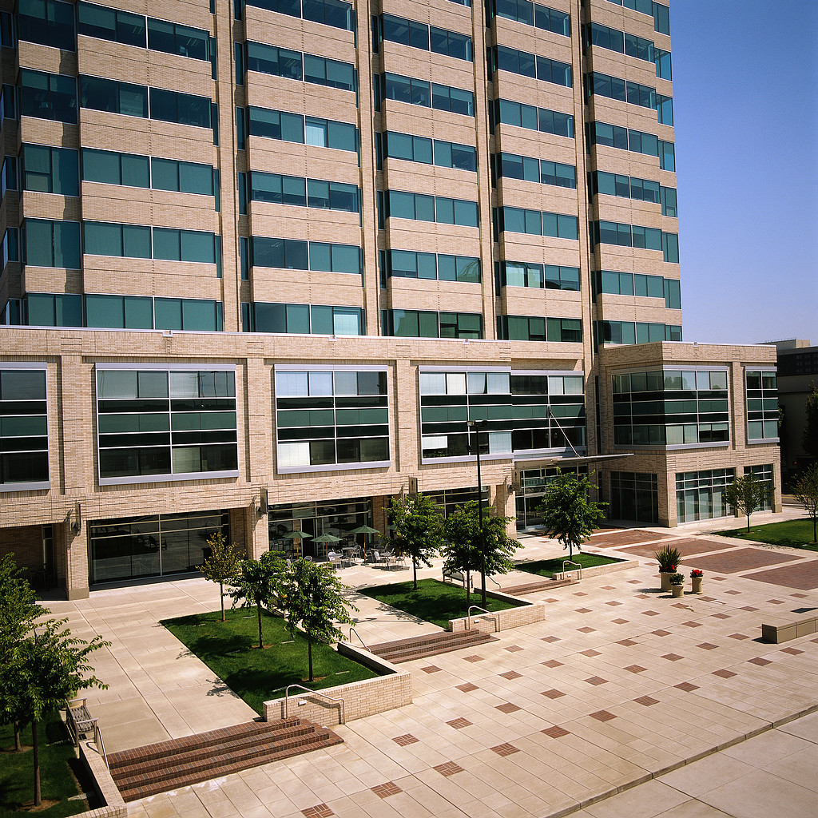 | Randy Mason’s  News You Can Use
July 29, 2026 | Volume 3
 | Follow These Five Tips for a Successful Tenant Improvement Project  Completing tenant improvements to a space can be an extremely exciting and rewarding project. There is always a sense of accomplishment when someone takes a blank canvass and creates a work of art, and the same idea could be true when one is building out a piece of real estate. The tips below will give you a starting point for creating a successful and efficient project and essentially your own work of art.  Create a Budget: It is important to set your budget objectives before you set your design objectives. Understand what makes financial sense for you or your business before you start your design. Explaining to your architect what you can afford can save you time and design fees. Once your design is complete and you’ve taken your plan to bid, it’s usually difficult to achieve significant savings. Often the architect will create a design that is above any realistic budget should they not be provided with the financial perimeters. Architects in general are creative individuals who like to see their ideas actualized; not to mention that you will also incur additional design fees to change your plan once it’s been created.  Generate a Complete and Accurate Plan: It’s important to spend what’s reasonably necessary to create and complete a plan that allows you to make a good decision. Often people are afraid to spend too much money on architectural and engineering plans at the front end of a project. Every build out is unique, so having a plan that addresses as many of the buildings complexities and unique attributes as possible can help you stay within your budget later on down the road. A simple space plan often misses items that can cost you big bucks later on.  Consult with a Contractor Up Front: Pay a few dollars and bring a contractor to meet with your architect when reviewing schematic drawings. Often times, what looks great on paper can translate into complexities in the field. Having a contractor present to bounce ideas off of can provide savings on materials and create a space that can be built simpler while maintaining the aesthetic properties that you are paying your architect for. Waiting until you’ve completed your design to see what it’s going to cost can hurt you in the long run. Design changes late in the game add unnecessary fees, adds time to your schedule, and once again, once a project is built its very difficult and costly to make changes.  Meet with the City Early on: While it may take a little extra time, setting up a pre-submittal meeting with the city agency can be time well spent. Taking a detailed conceptual plan to the building department prior to making a full submittal can save a lot of time and money. Meeting a plan checker at the counter to simply explain what your objectives are with the space and ask if they foresee any issues with your plan, can mean the difference between two plan checks and three, or possibly more. It is well worth your time because this will translate into fewer plan check fees and saving time on the overall schedule.  Have Competitive Construction Bids: It’s important to have at least three competitive bids in order to make sure you are getting the best pricing possible. It’s also important to make sure to look at each line item so the bids are considered apples to apples in comparison. Never presume the line item is inclusive and always ask questions and verify. If one bid is substantially higher than another, perhaps that contractor added some things that they knew were necessary, while another bid may have left those out.  One last note, It’s always a good idea to have a competent project coordinator on your side should you not be able to devote the time or have the experience necessary in completing a construction project. As a market leader in tenant representation, we offer the best and most complete corporate real estate services exclusively on behalf of the tenants or buyers. We don’t have a stake in both sides of the transaction that might compromise your outcome. We work exclusively under written contract with our clients. Our contract clearly spells out the services we provide and the obligations of the parties.
  “Find something you love to do and you'll never have to work a day in your life”
  -Harvey MacKay
  Randolph T. Mason
  CCIM, SIOR
  Senior Vice President at
  Lee & Associates
  Commercial Real Estate
  111 Pacifica Ste. 130
  Irvine, CA 92618
  P: (949)790-3113
  F: (949)727-1299
  C: (949)705-7000
  Email:
  rmason@lee-associates.com
  We’re on the Web!
  www.occree.com
  “Your work is to discover your world and then with all your heart give yourself to it.”
  -Buddha
  

